
IM Technical Specification Document

Revision History

Version | Date | Summary of Changes | Author
V1.0.0 | 3/19/2018 | First edition | Tony.yang
V1.0.1 | 4/19/2018 | V1.0.1 | Tony.yang

Technical Specification Sign-Off Signatory

_________________________  Prepared by Tony.yang  Designation: Application Architect |  | IT Department
_________________________  Reviewed by Xiaofei Wang  Designation: Deputy Technology Director |  | IT Department

Contents
1 Architecture Design 5
1.1 Design Philosophy 5
1.2 Technology Selection 5
1.3 Micro Service Unit and Dependencies 5
1.3.1 Services 6
1.3.2 Dependencies 6
1.4 UI Components 7
1.5 API Design 7
1.6 Publishing Event 9
1.7 Subscribing Event 10
2 Object Design 11
2.1 Message 11
2.2 Contact 11
2.3 Conversation 12
3 Database Design 12
3.1 Database Configuration 12
3.2 ER Diagram 12
4 Sequence Diagram Design 13
4.1 Connation API-GW Diagram 13
4.2 Push message Diagram 14
4.3 Pull unread message Diagram 14
4.4 Pull history message Diagram 15
4.5 Sync user status Diagram 15
4.6 Sync message status Diagram 16
5 IM Components Details 16
5.1 IM Component Design 16
6 IM System Structure 18

Architecture Design

Design Philosophy
(place your design idea here if necessary)
IM

Technology Selection
Technology | Reason
reactJS+mobx | UI framework
sockJS | JavaScript library that provides a WebSocket-like object in the browser
springBoot | stand-alone, production-grade Spring based Applications
gradle | project build tool
docker | Micro-services container
redis | Cache data
elastic search | persistence message

Micro Service Unit and Dependencies

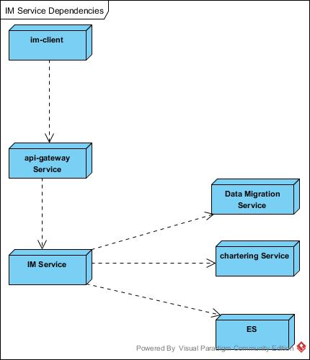

Services
Service | Description
IM-client | user chat tool by React UI Component
IM service | Provide contact ,messages,conversations management api

Dependencies
Dependency | Description
Api-gateway service | manage webscoket & inner services call
Data Migration Service | save&query user chat history messages
Chartering Service | Offer card informations manage

UI Components
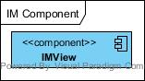

Components | Description
IMView | IM tools

API Design

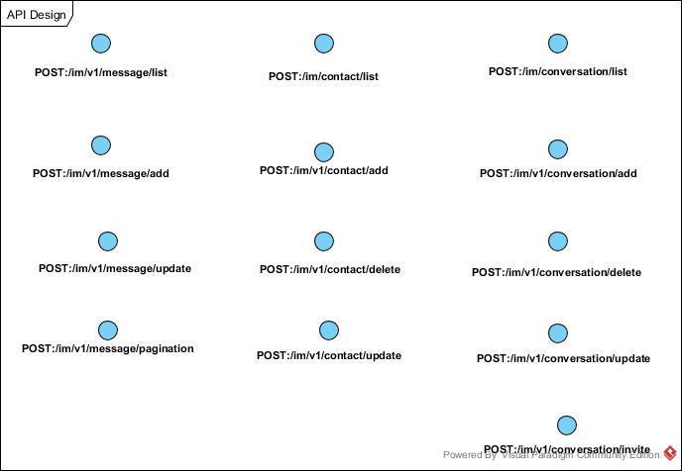

API | Input & Output
POST:/im/v1/message/add | Input:  {  messages:[mandatory,object:Message,nullable]  }  Successful Output:  {  result：[object: Message,nullable]  }  Failed Output:  {  error: "xxx"  }
POST:/im/v1/message/update | Input:  {  contactId:[mandatory, string, length:1-18]  messageId:[mandatory, string, length:1-18]  conversationId:[mandatory,string,length:1-18]  }  Successful Output:  {  result：[object: Message,nullable]  }  Failed Output:  {  error: "xxx"  }
POST:/im/v1/message/pagination | Input:  {  start:[mandatory, int]  pageSize:[mandatory, int]  condition:[optional,String ,nullable]  }  Successful Output:  {  result：[object: Message,nullable]  }  Failed Output:  {  error: "xxx"  }
POST:/im/v1/contact/list | Input:  {  contactId: [mandatory, string, length:1-18]  }  Successful Output:  {  result: [object: Contact,nullable]  Failed Output:  {  error: "xxxx"  }
POST:/im/v1/contact/add | Input:  {  contactId:[mandatory, string, length:1-18],  friends:[optional,object:Contact,nullable]  }  Successful Output:  {  result：[object: Contact,nullable]  }  Failed Output:  {  error: "xxx"  }
POST:/im/v1/contact/update | Input:  {  contactId:[mandatory, string, length:1-18],  friends:[mandatory,object:Contact,nullable]  }  Successful Output:  {  result：[object: Contact,nullable]  }  Failed Output:  {  error: "xxx"  }
POST:/im/v1/contact/delete | Input:  {  contactId: [mandatory, string, length:1-18],  friends: [optional,object:Contact,nullable]  }  Successful Output:  {  result: ”false” or ”true”  }  Failed Output:  {  error:"xxx"  }
POST:/im/v1/conversation/list | Input:  {  contactId: [mandatory, string, length:1-18]  }  Successful Output:  {  result: [object: Conversation,nullable]  }  Failed Output:  {  error: "xxxx"  }
POST:/im/v1/conversation/add | Input:  {  name: [optional, string, length:1-255],  icon: [optional, string, length:1-255],  createby: [mandatory,string, length:1-18],  contactIds :[mandatory, array]  }  Successful Output:  {  result:[object: Conversation,nullable]  }  Failed Output:  {  error: "xxxx"  }
POST:/im/v1/conversation/update | Input:  {  contactId: [mandatory, string, length:1-18],  Conversations:[object: Contact,nullable]  }  Successful Output:  {  result:[object: Conversation,nullable]  }  Failed Output:  {  error: "xxxx"  }
POST:/im/v1/conversation/delete | Input:  {  contactId: [mandatory, string, length:1-18],  conversationsId:[mandatory, string, length:1-18]  }  Successful Output:  {  result:[object: Conversation,nullable]  }  Failed Output:  {  error: "xxxx"  }
POST:/im/v1/conversation/invite | Input:  {  contactId: [mandatory, string, length:1-18],  contactIds:[mandatory, array],  conversationId: [mandatory, string, length:1-18],  }  Successful Output:  {  result:[object: Conversation,nullable]  }  Failed Output:  {  error: "xxxx"  }

Publishing Event
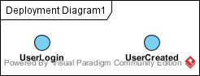

Event | Parameter
UserLogin | {  result: [“OK”, “ERR”],  token: [string, nullable],  user: [object: User, mandatory]  }
UserCreated | {  user: [object: User, mandatory]  }

Subscribing Event
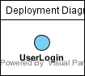

Event | Parameter
UserLogin | {  result: [“OK”, “ERR”],  token: [string, nullable],  user: [object: User, mandatory]  }

Object Design
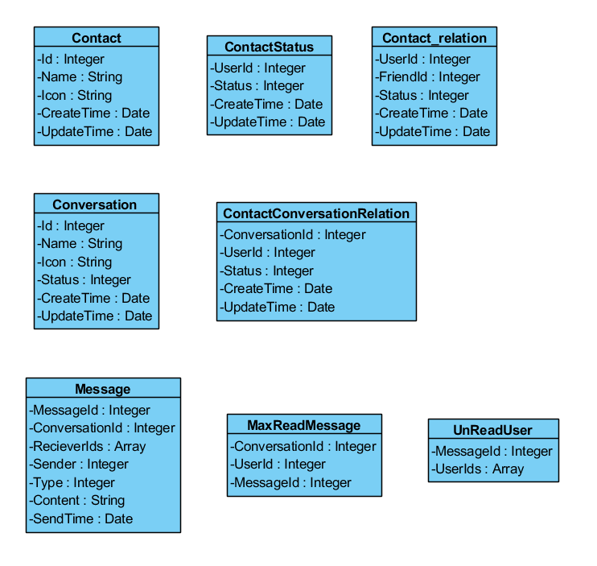

Message
Property | Data Type | Data Constraints
messageId | long
conversationId | long
type | String
content | String
senderId | long
senderTime | Date
status | String

Contact
Property | Data Type | Data Constraints
contactId | long
name | String
icon | String
status | String | Online /offline

Conversation
Property |  | Data Type | Data Constraints
conversationId | long
name | String
contactIds | Set<long>
members | String |  | “Jack,Kite,Jane…”
icon | String
status | String |  | Online /offline
unread | int
msgContent | String
msgDate | timestamp

Database Design

Database Configuration
Configuration | Value | Remark
Database Name | im
User Name | root
Password | root | For developer only
Default Charset | utf8mb4 | To support emoji
Dev DB Host | 192.168.48.89:23306
SIT DB Host
UAT DB Host
ID generator | Remote ID service

ER Diagram
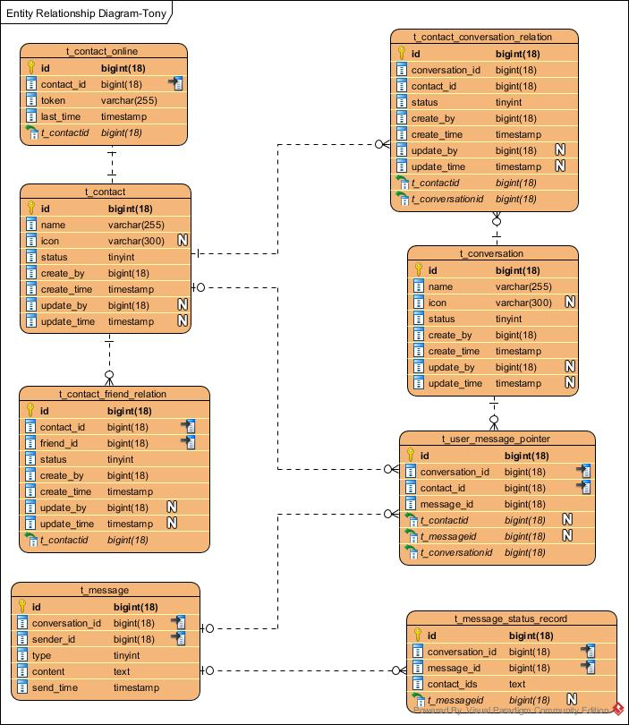

Sequence Diagram Design

Connation API-GW Diagram
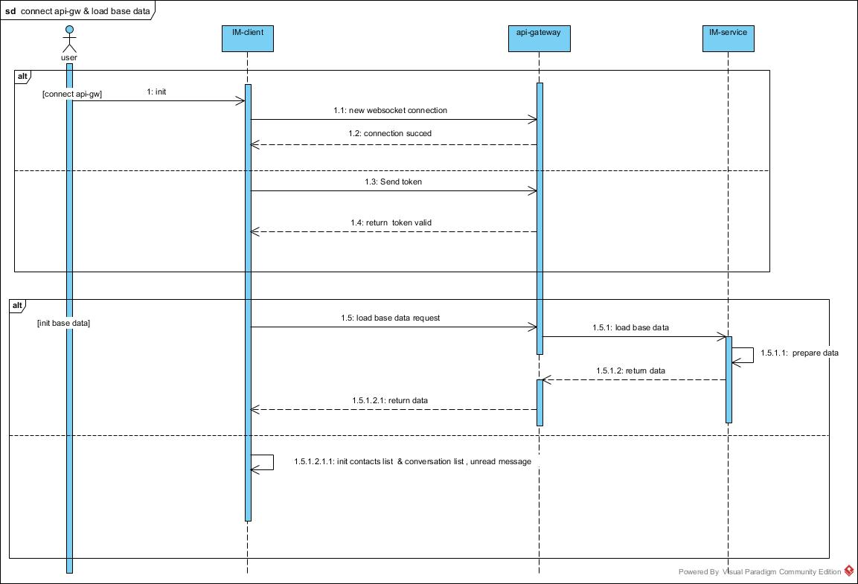

Push message Diagram
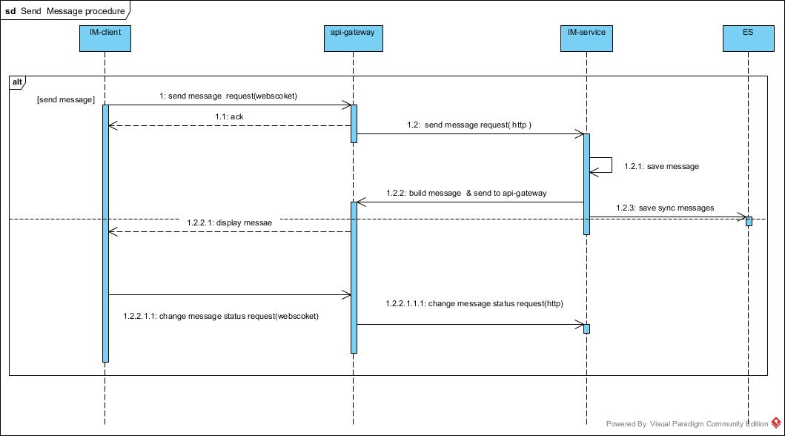

Pull unread message Diagram
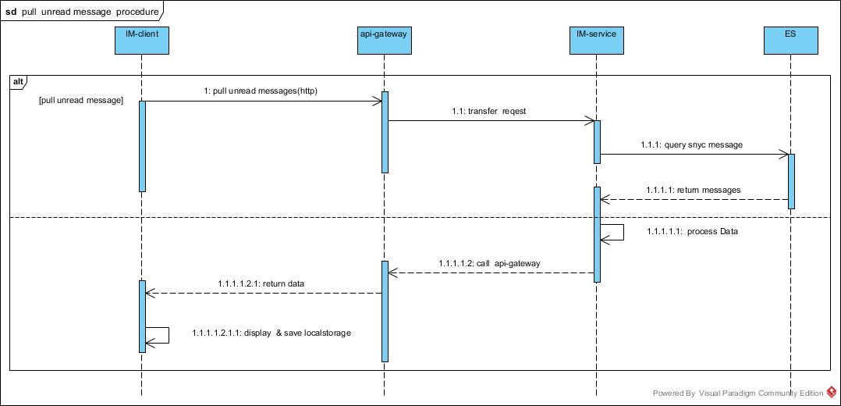

Pull history message Diagram
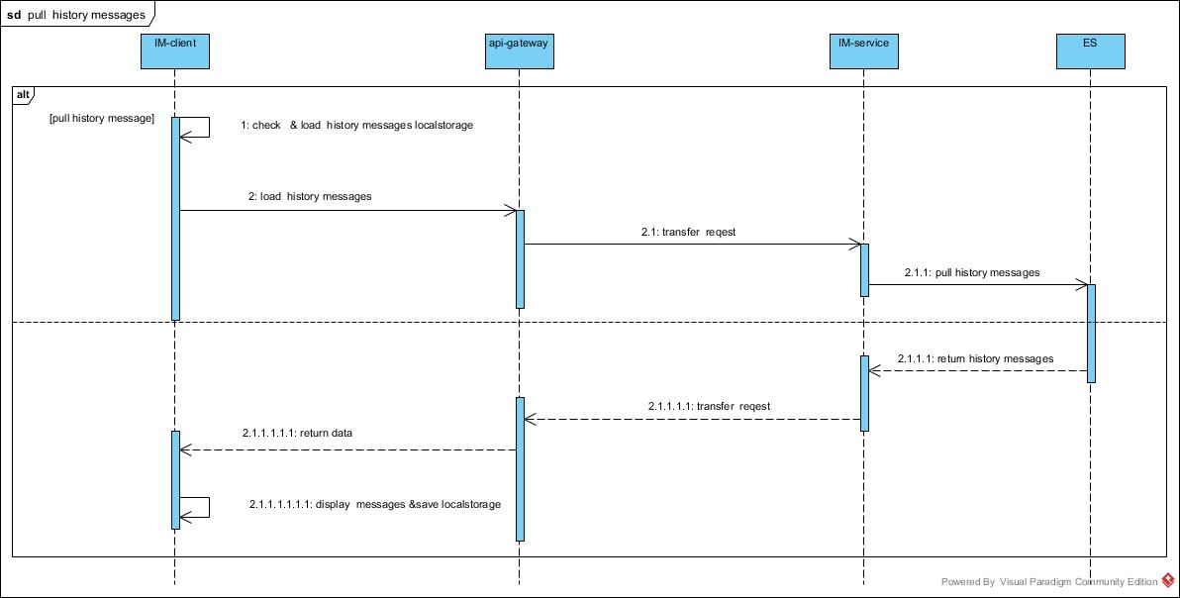

Sync user status Diagram
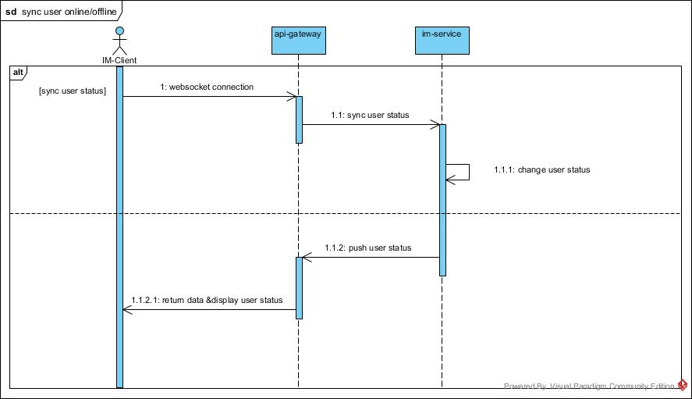

Sync message status Diagram
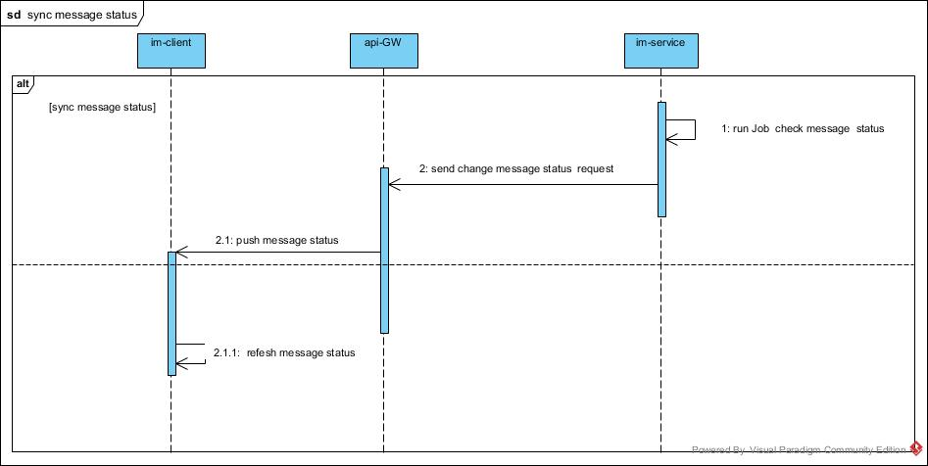

IM Components Details
IM components split details

IM Component Design
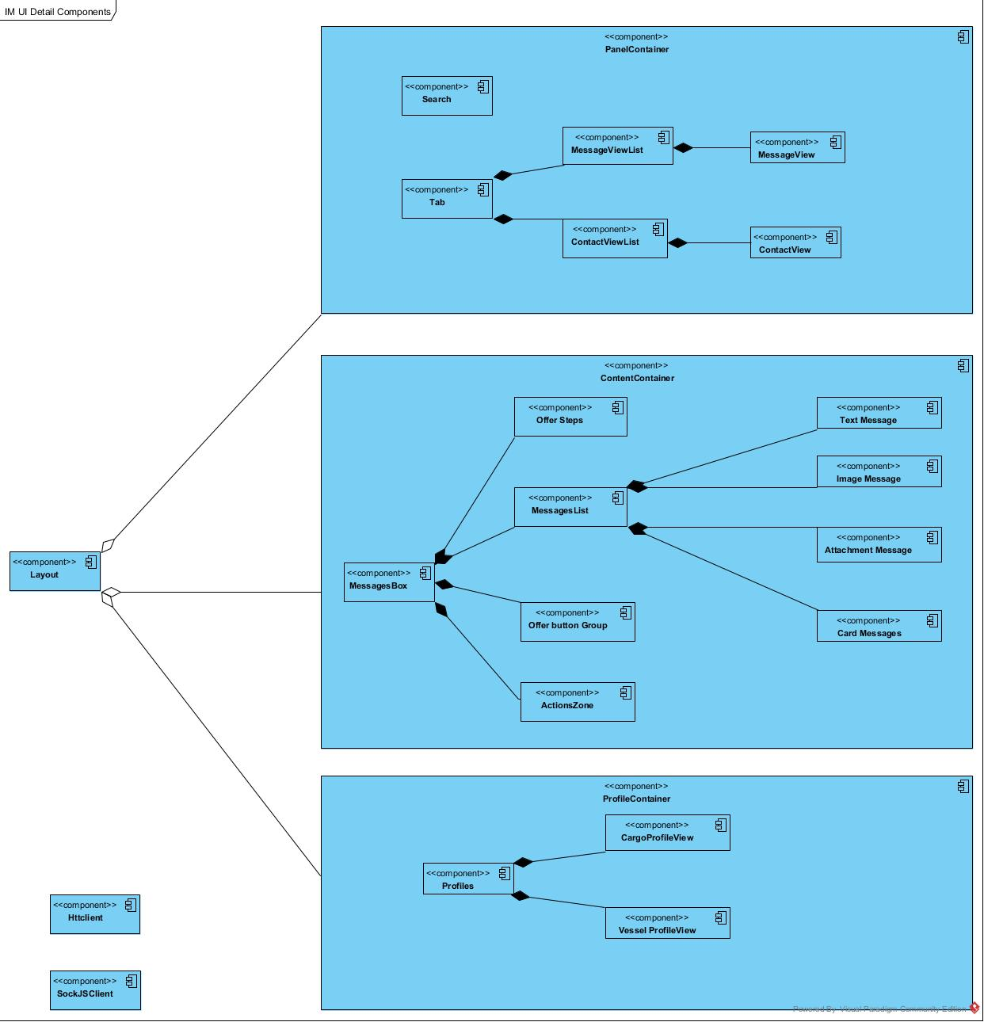

IM System Structure
